MSc BDS – Data Engineering and Machine Learning Operations in Business

MLOps Final Assignment:
Customer-Churn-MLOps Pipeline

Submitted by: Anzuman Ara
Student ID: 20241266

Submission Deadline: April 17, 2026

1. Introduction and Aim of the Project
Machine learning models are usually built and tested in stable environments, but their actual usefulness depends on how well they perform in real-world systems that keep changing over time. In practice, data is constantly updated, new information keeps coming in, and system needs may also change. Therefore, models must be regularly maintained, updated, and monitored to ensure they continue to give reliable results.
This project follows core MLOps principles, with a focus not only on model development but also on deployment, monitoring, and reproducibility, as discussed by Kreuzberger et al. (2023).
This project aims to design and implement a simplified yet realistic MLOps pipeline for customer churn prediction. The project emphasizes how different components of a machine learning system interact in a production-like setting. This includes handling both historical and newly arriving data, applying consistent preprocessing, training, and storing models, exposing predictions through an API, and monitoring system behavior through logging.
Customer churn prediction is chosen as a case study because it is a common business problem that involves structured data and repeated prediction tasks. The pipeline is carefully built in a modular and transparent way so that each part can be easily understood, tested, and improved separately. This matches real-world MLOps practices, where maintainability, reproducibility, and system reliability are often more important than just achieving high model performance.
The objective of this project is to simulate a real-world production pipeline where:
- Data is continuously ingested and updated
- Preprocessing and feature engineering are applied consistently
- Models are trained and versioned
- Predictions are served through an API
- System behavior is monitored through logs
The system is designed to be modular, reproducible, and deployable, reflecting industry practices in machine learning operations (MLOps).

2. Pipeline Diagram
Historical Data + New Data
↓
Data Ingestion
↓
Preprocessing & Feature Engineering
↓
Model Training
↓
Artifact Storage (model, metrics, schema)
↓
FastAPI Prediction Service
↓
Monitoring & Logging System
↓
Dockerized Deployment
Figure 1: End-to-end MLOps pipeline for customer churn prediction

3. Technical Details of Each Pipeline Component

3.1 Data Ingestion
The system uses a batch-based ingestion strategy. Historical data is stored locally in CSV format, while new incoming data is simulated and added to the dataset using an ingestion script. The pipeline also follows data-centric AI principles, where keeping data reliable and up to date is important for building robust machine learning systems (Zha et al., 2025)
The ingestion process:
- Reads historical data
- Generates or loads new data
- Added it to the dataset
- Logs ingestion events
CSV format is used because the dataset is structured and does not require complex relational queries. This simplifies implementation while still demonstrating the ingestion pipeline.

3.2 Preprocessing
The preprocessing stage ensures consistency between training and inference. The following steps are applied:
- missing values are handled using default imputation
- numerical columns are converted to appropriate types
- categorical variables are encoded using one-hot encoding
- irrelevant identifiers (e.g., customer ID) are removed
Consistent preprocessing is critical in MLOps systems to avoid training-serving skew.

3.3 Feature Engineering
A derived feature is introduced:
- average monthly value = MonthlyCharges / (tenure + 1)
This feature captures the relationship between customer lifetime and spending behavior.
Feature engineering is intentionally kept simple to emphasize pipeline design rather than model complexity.
3.4 Model Training
A Random Forest classifier is used for training due to its robustness and suitability for tabular data.
The training step:
- loads processed data
- splits features and target
- trains the model
- stores artifacts
Stored artifacts:
- trained model
- feature schema
- evaluation metrics
Random Forest is selected because it can effectively handle different types of data without requiring extensive preprocessing. It is also less sensitive to overfitting compared to many other algorithms and generally performs well with minimal parameter tuning, making it a practical and reliable choice for this project.

4. Evaluation, Monitoring, and Versioning Strategy

4.1 Evaluation
Model performance is evaluated using accuracy.
However, accuracy alone is not enough in real-world systems. Other evaluation metrics, such as precision and recall, are also important depending on the business goal. For example, in customer churn prediction, reducing false negatives may be more important to avoid losing valuable customers.
Evaluation is built into the pipeline as an ongoing process rather than being handled as a separate final step. This allows the model’s performance to be checked continuously throughout the workflow, making it easier to detect issues early, maintain reliability, and ensure that the system continues to perform well as new data is introduced.

4.2 Monitoring
Monitoring is implemented using logging mechanisms:
• Ingestion logs are used to record when new data is received, added, or updated in the system. This helps track changes in the dataset over time and ensures that the data pipeline is working correctly.
• Prediction logs store the model’s input data along with the corresponding output predictions. This makes it possible to review how the model behaved for specific cases.
This allows:
• Traceability of predictions, meaning each prediction can be linked back to the input data that produced it.
• Detection of anomalies, such as unusual prediction patterns, missing values, or unexpected changes in incoming data.
• Easier debugging of system behavior, since logs provide a clear record of what happened at each stage of the pipeline.
Future improvements:
• Data drift detection can be added to identify changes in the pattern or distribution of incoming data over time.
• Performance degradation alerts can be introduced to notify users when the model’s accuracy or reliability starts to decline.

4.3 Versioning
Artifacts are versioned implicitly through file storage:
• Datasets are stored in separate files, which helps preserve the original historical data and any updated versions over time.
• Processed data files are saved after each transformation step, making it easier to track changes made during preprocessing.
• Model files are stored whenever a new model is trained, allowing different trained versions to be kept for comparison or reuse.
• Logs are also saved as records of system activity, helping track updates, predictions, and system behavior over time.
Versioning supports reproducibility by making it possible to repeat the same workflow and obtain consistent results. It also allows rollback to previous versions of data or models if errors occur or if a newer version performs worse.

5. Artifact Collection and Storage
Proper artifact management improves traceability and reproducibility throughout the machine learning lifecycle. By keeping track of datasets, processed files, model versions, and logs, it becomes easier to understand how results were produced and to repeat the same workflow when needed. This is an important requirement in production systems, where reliability, consistency, and the ability to troubleshoot issues are essential. (Schlegel & Sattler, 2022)
Artifacts are stored in a structured directory:
- raw data (historical, new)
- processed data
- trained model (model.pkl)
- feature schema (columns.pkl)
- evaluation metrics
- logs
Why important:
Artifact storage enables:
- reproducibility
- debugging
- auditability

6. Deployment Setup

6.1 API Deployment
The model is deployed using FastAPI, exposing a /predict endpoint.
Why FastAPI:
- lightweight
- fast
- built-in documentation (Swagger)
- easy integration with ML models
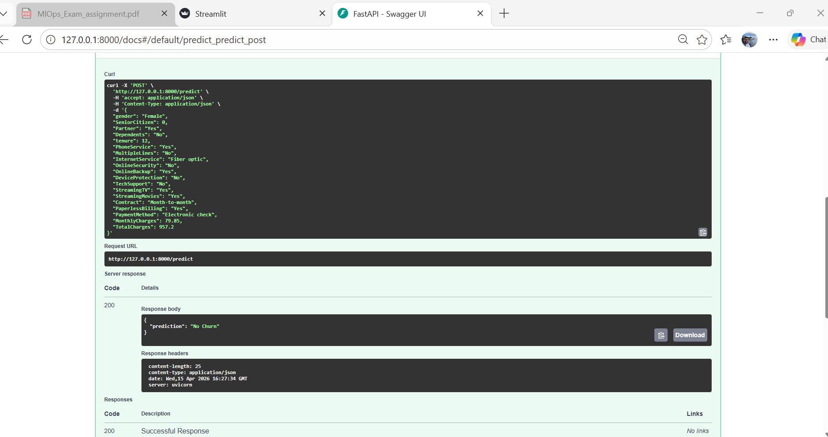
Figure 2: FastAPI Swagger UI showing successful churn prediction.

6.2 Docker Deployment
The entire system is containerized using Docker.
Steps:
- build image
- run container
- expose port 8000
Why Docker:
- ensures environmental consistency
- simplifies deployment
- supports reproducibility

6.3 Execution Mode
The system supports:
- on-demand predictions through the FastAPI API,
- interactive user predictions through the Streamlit frontend,
- continuous execution through Docker container deployment.

7. Frontend
A lightweight interactive frontend was implemented using Streamlit to improve usability and demonstrate end-user interaction.
The frontend allows users to:
- enter customer details through a simple form,
- send data to the FastAPI backend,
- receive real-time churn predictions.
The frontend communicates with the deployed FastAPI API through the /predict endpoint.
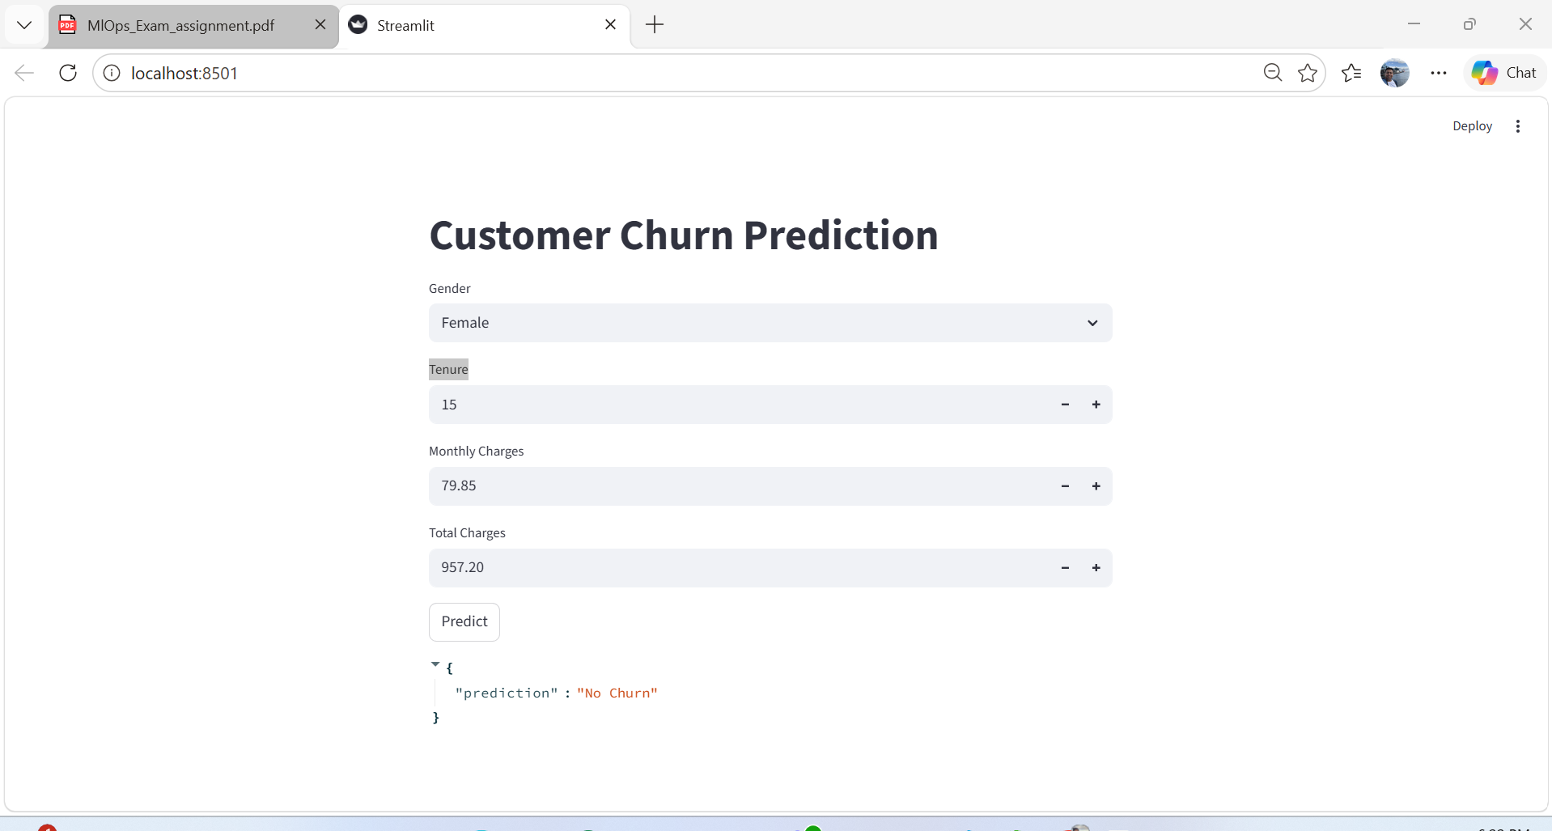
Figure 3: Streamlit frontend used for customer churn prediction.

Why Streamlit:
- simple and fast to develop,
- easy integration with Python APIs,
- suitable for demonstrating machine learning applications.
This frontend improves the accessibility of the system and provides a more realistic deployment scenario.

8. Conclusion
This project demonstrates a complete MLOps pipeline focusing on system design, modularity, and deployment. The pipeline successfully brings together all the main stages of the machine learning workflow, including data ingestion, preprocessing, model training, deployment, and monitoring. By connecting these components into a single system, it ensures that data can move smoothly through each stage and that the model can be updated, used, and tracked in a reliable and organized way.
The design reflects real-world machine learning systems, where reproducibility, scalability, and maintainability are more important than model accuracy alone.

References
Kreuzberger, D., Kühl, N., & Hirschl, S. (2023). Machine Learning Operations (MLOps): Overview, Definition, and Architecture. IEEE Access, 11, 31866–31879.
Schlegel, M., & Sattler, K.-U. (2022). Management of Machine Learning Lifecycle Artifacts: A Survey. SIGMOD Record, 51(4), 18–35.
Zha, D., Bhat, Z. P., Lai, K.-H., et al. (2025). Data-centric Artificial Intelligence: A Survey. ACM Computing Surveys, 57(5), Article 129.

